**Assignment -1**

Python Programming

|  |  |
| --- | --- |
| Assignment Date | 19 September 2022 |
| Student Name | Sanjay Kumar S |
| Student Roll Number | 722819104126 |
| Maximum Marks | 2 Marks |

**Question-1:** Develop a sample homepage with html, css which should include banner, image & description about yourself and contact form.

**Question-2:** create responsive page for mobile as well as desktop.

Both have same answer

Index.html

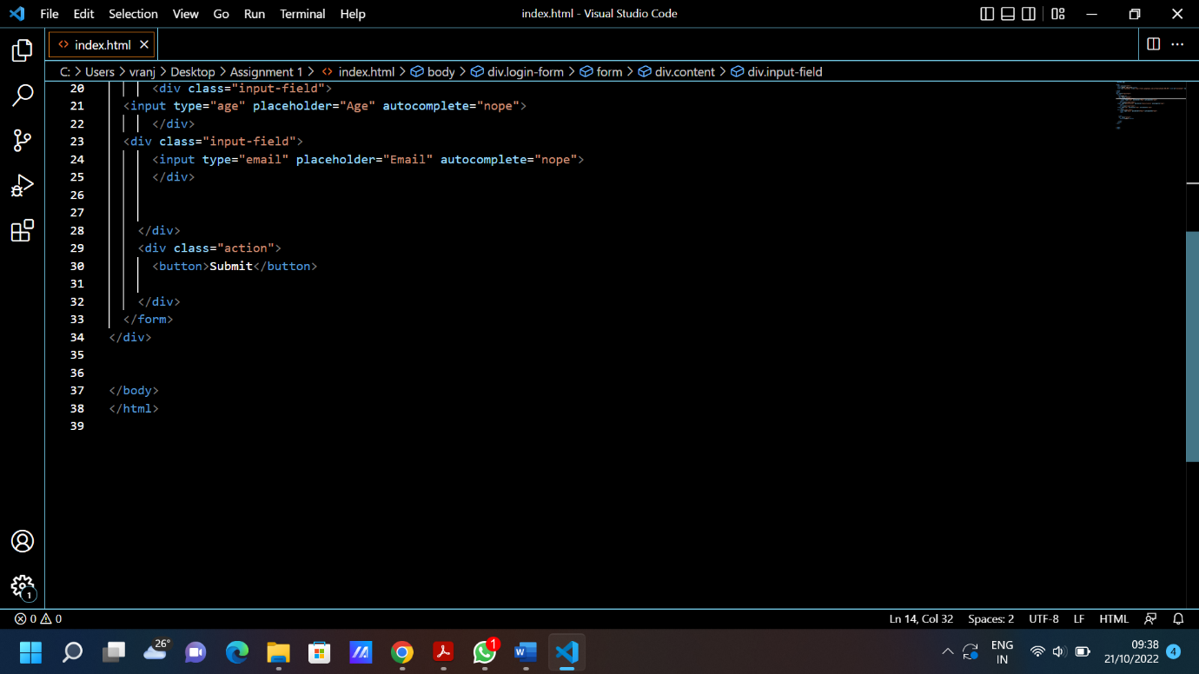

|  |  |
| --- | --- |
| Style.css |  |